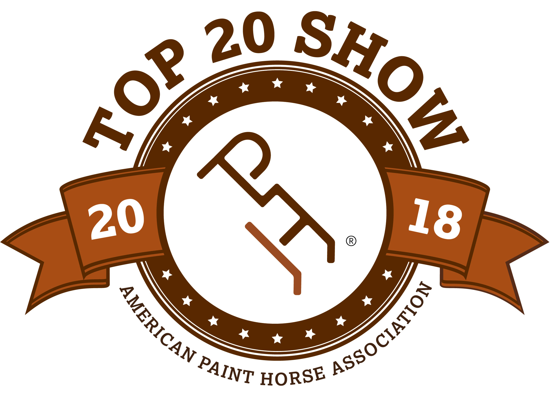

APHA Zone 5 ZONE-O-RAMA

April 27-28, 2019

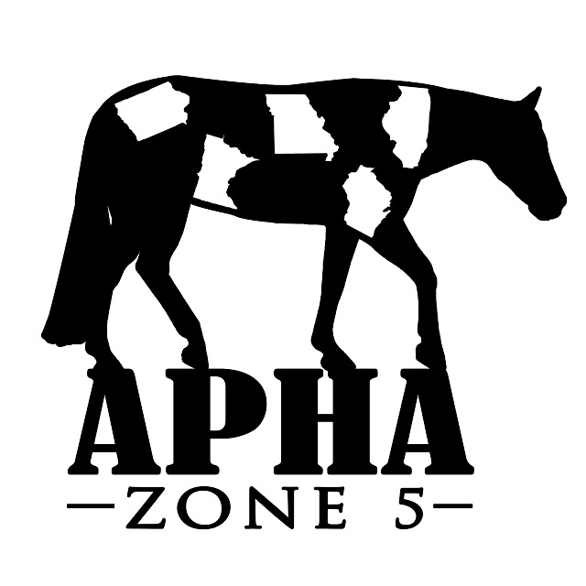

BACK #

**HORSE REGISTRATION PAPERS MUST BE IN HAND FOR VERIFICATION OF OWNERSHIP. CURRENT MEMBERSHIP CARDS, BOTH OWNER & EXHIBITOR MUST BE PRESENTED AT THE SHOW.**

Name of person who will be paying this horses’ fees:

HORSE INFORMATION (As it appears on the Registration Papers)

* Mare
* Gelding
* Stallion

SPB?

* Yes
* No

Registered Name Reg #

Trainer/Stalled With Foal Year

OWNER INFORMATION (As it appears on the Registration Papers)

Owner APHA # Exp. Date

{jpj

Address City, State, Zip

Email Phone

EXHIBITOR INFORMATION   
DP)

|  |  |  |  |  |
| --- | --- | --- | --- | --- |
| ***Status*** |  |  | ***APHA/AJPHA #*** | ***EXP. DATE*** |
| Open |  |  |  |  |
| Amateur |  |  |  |  |
| Nov. Am |  |  |  |  |
| Youth |  |  |  |  |
| Nov. Youth |  |  |  |  |

**EXHIBITOR 1**

Address

City, State, Zip

Phone Email

Relationship to Owner DOB

|  |  |  |  |  |
| --- | --- | --- | --- | --- |
| ***Status*** |  |  | ***APHA/AJPHA #*** | ***EXP. DATE*** |
| Open |  |  |  |  |
| Amateur |  |  |  |  |
| Nov. Am |  |  |  |  |
| Youth |  |  |  |  |
| Nov. Youth |  |  |  |  |

**EXHIBITOR 2**

Address

City, State, Zip

Phone E Email

Relationship to Owner DOB

|  |  |  |  |  |
| --- | --- | --- | --- | --- |
| ***Status*** |  |  | ***APHA/AJPHA #*** | ***EXP. DATE*** |
| Open |  |  |  |  |
| Amateur |  |  |  |  |
| Nov. Am |  |  |  |  |
| Youth |  |  |  |  |
| Nov. Youth |  |  |  |  |

**EXHIBITOR 3**

Address

City, State, Zip

Phone Email

Relationship to Owner DOB

|  |  |  |  |  |  |  |  |  |  |  |  |
| --- | --- | --- | --- | --- | --- | --- | --- | --- | --- | --- | --- |
|  |  | EXHIB # | |  |  | EXHIB # | |  |  | EXHIB # | |
|  |  | SAT | SUN |  |  | SAT | SUN |  |  | SAT | SUN |
|  | **NSBA** |  |  |  | **YOUTH/NOVICE YOUTH (cont’d)** |  |  |  | **OPEN** |  |  |
| 500 | Youth Performance Mares |  |  | 87 | Youth Hunter U/Saddle 18/U |  |  | 2 | Pleasure Driving |  |  |
| 501 | Amateur Performance Mares |  |  | 92 | Novice Yth Hunt Seat Equitation |  |  | 14 | Performance Halter Mares |  |  |
| 502 | Performance Halter Mares |  |  | 94 | Youth Hunt Seat Eq 13/U |  |  | 15 | 4 & Over Aged Mares |  |  |
| 503 | Novice Yth Showmanship 18/U |  |  | 95 | Youth Hunt Seat Eq 18/U |  |  | 16 | 3-Year Old Mares |  |  |
| 504 | Novice Amateur Showmanship |  |  | 98 | Youth Western Riding |  |  | 17 | 2-Year Old Mares |  |  |
| 505 | Youth Showmanship 13/U |  |  | 102 | Youth Reining |  |  | 18 | Yearling Mares |  |  |
| 506 | Youth Showmanship 18/U |  |  | 105 | Youth Ranch Riding |  |  | 21 | Junior SPB Mares, 2 & Under |  |  |
| 507 | Amateur Showmanship |  |  | 108 | Youth Barrel Racing |  |  | 22 | Senior SPB Mares, 3 & Over |  |  |
| 508 | Youth Performance Geldings |  |  | 114 | Novice Youth Trail 18/U |  |  | 46 | Performance Halter Geldings |  |  |
| 509 | Amateur Performance Geldings |  |  | 116 | Youth Trail 18/U |  |  | 47 | 4 & Over Aged Geldings |  |  |
| 510 | Performance Halter Geldings |  |  | 124 | Youth Lead Line |  |  | 48 | 3-Year Old Geldings |  |  |
| 511 | Amateur Performance Stallions |  |  | 132 | Novice Youth Western Pleasure |  |  | 49 | 2-Year Old Geldings |  |  |
| 512 | Performance Halter Stallions |  |  | 134 | Youth Western Pleasure 13/U |  |  | 50 | Yearling Geldings |  |  |
| 513 | Green Hunter Under Saddle |  |  | 135 | Youth Western Pleasure 18/U |  |  | 53 | Junior SPB Geldings 2 & Under |  |  |
| 514 | Junior Hunter Under Saddle |  |  | 140 | Novice Youth Horsemanship |  |  | 54 | Senior SPB Geldings 3 & Over |  |  |
| 515 | Novice Youth Hunter U/Saddle |  |  | 142 | Youth Horsemanship 13/U |  |  | 57 | Overo Color |  |  |
| 516 | Novice Amat Hunter U/Saddle |  |  | 143 | Youth Horsemanship 18/U |  |  | 58 | Tobiano Color |  |  |
| 517 | Youth Hunter U/Saddle 13/U |  |  |  |  |  |  | 66 | Performance Halter Stallions |  |  |
| 518 | Youth Hunter U/Saddle 18/U |  |  |  | **YOUTH WALK-TROT 5-10** |  |  | 67 | 4 & Over Aged Stallions |  |  |
| 519 | Amateur Hunter Under Saddle |  |  | 27 | Youth W-T Showmanship |  |  | 68 | 3-Year Old Stallions |  |  |
| 520 | Senior Hunter Under Saddle |  |  | 79 | Youth W-T Hunter U/Saddle |  |  | 69 | 2-Year Old Stallions |  |  |
| 521 | Novice Youth Hunt Seat Eq |  |  | 81 | Youth W-T Hunt Seat Eq |  |  | 70 | Yearling Stallions |  |  |
| 522 | Novice Amateur Hunt Seat Eq |  |  | 111 | Youth W-T Trail |  |  | 73 | Junior SPB Stallions, 2 & Under |  |  |
| 523 | Youth Hunt Seat Eq 13 & Under |  |  | 126 | Youth W-T Western Pleasure |  |  | 74 | Senior SPB Stallions, 3 & Over |  |  |
| 524 | Youth Hunt Seat Eq 18 & Under |  |  | 128 | Youth W-T Horsemanship |  |  | 78 | Green Hunter Under Saddle |  |  |
| 525 | Amateur Hunt Seat Equitation |  |  |  |  |  |  | 83 | Junior Hunter Under Saddle |  |  |
| 526 | Youth Western Riding 18/U |  |  |  | **AMATEUR/NOVICE AMATEUR** | |  | 90 | Senior Hunter Under Saddle |  |  |
| 527 | Green Western Riding |  |  | 1 | Amateur Pleasure Driving |  |  | 91 | SPB Hunter Under Saddle |  |  |
| 528 | Amateur Western Riding |  |  | 7 | Amateur Mares, All Ages |  |  | 99 | Green Western Riding |  |  |
| 529 | Western Riding |  |  | 8 | Amateur Performance Mares |  |  | 101 | Western Riding |  |  |
| 530 | Green Trail |  |  | 11 | Amateur SPB Mares All Ages |  |  | 104 | Reining |  |  |
| 531 | Novice Youth Trail 18 & Under |  |  | 30 | Novice Amateur Showmanship |  |  | 107 | Ranch Riding |  |  |
| 532 | Novice Amateur Trail |  |  | 33 | Amateur Showmanship |  |  | 110 | Barrel Racing |  |  |
| 533 | Youth Trail, 18 & Under |  |  | 34 | Amateur SPB Showmanship |  |  | 113 | Green Trail |  |  |
| 534 | Amateur Trail |  |  | **39** | Amateur Geldings, All Ages |  |  | 119 | Trail |  |  |
| 535 | Trail |  |  | 40 | Amateur Performance Geldings |  |  | 120 | SPB Trail |  |  |
| 536 | Green Western Pleasure |  |  | 43 | Amateur SPB Geldings All Ages |  |  | 125 | Green Western Pleasure |  |  |
| 537 | Junior Western Pleasure |  |  | 59 | Amateur Stallions, All Ages |  |  | ***130*** | ***Zone 5 Charity Open Walk-Trot*** |  |  |
| 538 | Novice Youth Western Pleasure |  |  | 60 | Amateur Performance Stallions |  |  | 131 | Junior Western Pleasure |  |  |
| 539 | Novice Am Western Pleasure |  |  | 63 | Amateur SPB Stallions All Ages |  |  | 138 | Senior Western Pleasure |  |  |
| 540 | Youth Western Pleasure 13/U |  |  | 85 | Novice Amat Hunter U/Saddle |  |  | 139 | SPB Western Pleasure |  |  |
| 541 | Youth Western Pleasure 18/U |  |  | 88 | Amateur Hunter Under Saddle |  |  |  | Horses are entered at your own risk and are subject to each specific association rules under which these classes will be conducted. In case of death, accident, injury or theft to the exhibitor, their family, horses or property, no claims will be honored either against this show or managing facility. |  |  |
| 542 | Amateur Western Pleasure |  |  | 89 | Amateur SPB Hunter U/Saddle |  |  |  |  |  |  |
| 543 | Senior Western Pleasure |  |  | 93 | Novice Amateur Hunt Seat Eq |  |  |  |  |  |  |
| 544 | Novice Youth Horsemanship |  |  | 96 | Amateur Hunt Seat Eq |  |  |  |  |  |  |
| 545 | Novice Amateur Horsemanship |  |  | 97 | Amateur SPB Hunt Seat Eq |  |  |  |  |  |  |
| 546 | Youth Horsemanship 13/U |  |  | 100 | Amateur Western Riding |  |  |  |  |  |  |
| 547 | Youth Horsemanship 18/U |  |  | 103 | Amateur Reining |  |  |  |  |  |  |
| 548 | Amateur Horsemanship |  |  | 106 | Amateur Ranch Riding |  |  |  |  |  |  |
|  | **ZONE 5 LIMITED CLASSES** |  |  | 109 | Amateur Barrel Racing |  |  |  |  |  |  |
| 25 | Novice Non Pro Showmanship |  |  | 115 | Novice Amateur Trail |  |  |  |  |  |  |
| 26 | Non Pro Showmanship |  |  | 117 | Amateur Trail |  |  |  |  |  |  |
| 77 | Non Pro Hunter Under Saddle |  |  | 118 | Amateur SPB Trail |  |  | ***Please complete and email to*** [***westphal@partnercom.net***](mailto:westphal@partnercom.net) ***or mail to***  ***Cindy Westphal***  ***13696 N. 107th Ave E***  ***Gilman, IA 50106*** | | | |
| 121 | Non Pro Walk-Trot West Pleas. |  |  | 133 | Novice Am Western Pleasure |  |  |
| 122 | Novice Non Pro West Pleasure |  |  | 136 | Amateur Western Pleasure |  |  |
| 123 | Non Pro Western Pleasure |  |  | 137 | Amateur SPB Western Pleasure |  |  |
|  |  |  |  | 141 | Novice Amateur Horsemanship |  |  |
|  | **YOUTH/NOVICE YOUTH** |  |  | 144 | Amateur Horsemanship |  |  |
| 3 | Youth Mares, All Ages |  |  | 145 | Amateur SPB Horsemanship |  |  |
| 4 | Youth Performance Mares |  |  |  | **AMATEUR WALK-TROT** |  |  |
| 29 | Novice Yth Showmanship 18/U |  |  | 28 | Amateur W-T Showmanship |  |  |  |  |  |  |
| 31 | Youth Showmanship 13/U |  |  | 80 | Amateur W-T Hunter U/Saddle |  |  | # of Stalls__________ # of Tack Stalls ________  # of Shavings_______ # Nights Camping______  Pattern Book Y / N | | | |
| 32 | Youth Showmanship 18/U |  |  | 82 | Amateur W-T Hunt Seat Eq |  |  |
| 35 | Youth Geldings, All Ages |  |  | 112 | Amateur W-T Trail |  |  |
| 36 | Youth Performance Geldings |  |  | 127 | Amateur W-T Western Pleasure |  |  |
| 84 | Novice Youth Hunter U/Saddle |  |  | 129 | Amateur W-T Horsemanship |  |  |
| 86 | Youth Hunter U/Saddle 13/U |  |  |  |  |  |  |