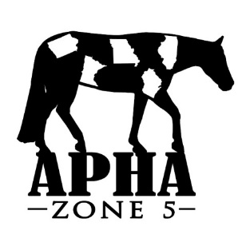
APHA Zone 5 Show – April 27-28, 2019
Stall & Bedding Reservations
NO REFUNDS after April 12, 2019
Reservations MUST be made on this form with accompanying check
***No reservations will be accepted or final until payment has been received***

Name __________________________________________________________________
Street Address ___________________________________________________________
City/State/Zip ____________________________________________________________
Phone Number ____________________________Email: _______________________________
Check box to receive a confirmation email when your reservation has been received
#_____ Horse Stalls @ $70 per stall = $ ___________
#_____ Tack Stalls @ $70 per stall = $ ___________
#_____Bedding @ $8.00 per bag = $ ___________
(2 bags of bedding are required to be purchased, per horse stall)

#_____ Early Arrival Fee @ $30 per horse (no fee for tack stalls) = $ ___________
(Early arrival is after 5 p.m. on Thursday 4/25/19), If arriving Friday after 8 a.m., no fee will be charged.
There will be NO ONE to deliver bedding on Thursday, so you if you need bedding, you MUST pre-order.

Total Amount $ _________
Stalling with: (all checks/forms must be submitted at the same time to guarantee placement together)
NAME Phone Number/Email
________________________ _____________________________________
________________________ _____________________________________

Special Notes** If you feel you may need to alter your stall count before 4/12/19, please leave your check blank, otherwise, you will need to mail in a new one for the corrected amount. Additions in the same location are not guaranteed if the main barn fills before you communicate your change.
Checks will be deposited 4/15/19. **Once the main barn is full, reservations will start in the North barn. This barn is attached to the show arena, but once the show starts horses must go around outside to enter the warm-up/show pen. If you are worried you could be in North barn, please call, text, or email to check on the status before sending payment. There are no refunds on stalls after April 12, 2019. If there are cancellations in the main barn, those in the North Barn will be moved to the main barn in the order the reservations were received.
** Camping Reservations required and assigned, see separate form.

Mail Completed form and payment to: CHECKS PAYABLE TO APHA ZONE 5
Lindsay McLain
524 Carrie Lane
Altoona, Iowa 50009
Phone: 515-491-5111 Email: LBG81@aol.com

