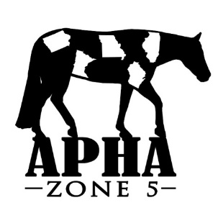
APHA Zone 5 Show – April 27-28, 2019
Camping Reservations

Reservations MUST be made on this form with accompanying check
***No reservations will be accepted or final until payment has been received***

Name __________________________________________________________________
Street Address ___________________________________________________________
City/State/Zip ____________________________________________________________
Phone Number ____________________________Email: _______________________________
Check box to receive a confirmation email when your reservation has been received
$25 per spot, per night
______ Nights x ______ Spots x $25 = $ ___________

***All camping spots will be ASSIGNED. If you park in a spot that is not assigned to you, you will be required to move. ***Saving spots will not be allowed***
Preferred Camping Spot # _____________ (see map on www.iowapainthorseclub.com under Zone 5 tab)
***Camping will be assigned based on date of receipt. If your preference is taken, every effort will be made to get you as close as possible to your preferred spot.

Total Amount $ _________
Camping with: (all checks/forms must be submitted at the same time to guarantee placement together)
NAME Phone Number/Email
________________________ _____________________________________
________________________ _____________________________________

Mail Completed form and payment to: CHECKS MADE PAYABLE TO APHA ZONE 5
Lindsay McLain
524 Carrie Lane
Altoona, Iowa 50009
Phone: 515-491-5111 Email: LBG81@aol.com

