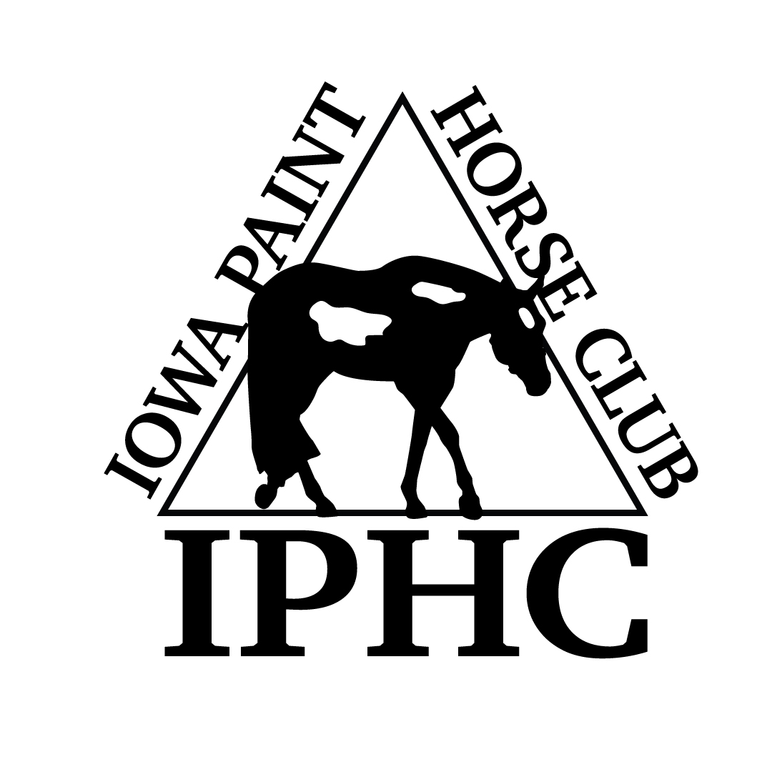
HORSE REGISTRATION PAPERS MUST BE IN HAND FOR VERIFICATION OF OWNERSHIP. CURRENT MEMBERSHIP CARDS, BOTH OWNER & EXHIBITOR MUST BE PRESENTED AT THE SHOW.
IOWA PAINT HORSE CLUB – 2018 OCTOBER ENTRY FORM
Back #
April 26-27, 2014 2014

Name of person who will be paying this horses’s fees:

HORSE INFORMATION (As it appears on the Registration Papers)

- Mare
- Gelding
- Stallion
Registered Name Reg. #: Foal Year

Trainer/Stalled With
SPB Y/N

OWNER INFORMATION (As it appears on the Registration Papers)

{jpj

Owner APHA # Exp.Date Phone #

Address City,State, Zip

Email

EXHIBITOR INFORMATION (Date of Birth “DOB” required for Youth only)
DP)

EXHIBITOR # 1

EXHIBITOR # 2
Name  APHA # Exp.Date DOB  Address  City,State,Zip  Phone Email  Relationship to Owner  Rider Status: ___ Open ____Amateur ____Novice _____Youth | Name  APHA # Exp.Date DOB  Address  City,State,Zip  Phone Email  Relationship to Owner  Rider Status: ___ Open ____Amateur ____Novice _____Youth
# 1  EXHIBITOR # 3  Name  APHA # Exp.Date DOB  Address  City,State,Zip  Phone Email  Relationship to Owner  Rider Status: ___ Open ____Amateur ____Novice _____Youth | SHOW FEES – 4 JUDGE P-O-R  PRE-PAYMENT FOR STALLS & SHAVINGS IS REQUIRED  ALL FEES REPRESENT A PER DAY/PER HORSE FEE  FEES INCLUDE ALL FEES AND # OF CLASSES INDICATED  - 4 CLASSES OR MORE - $160/PER HORSE  - 2-3 CLASSES - $110/PER HORSE  - 1 CLASS - $60/PER HORSE  - STALLS: $70, Shavings $8.50 on or before 10/1/28. Stalls $80, Shavings $9.50 10/2/18 through day of show. See stall form on www.iowapainthorseclub.com under Show Schedule. NO JUMP OUTS ALLOWED.  - Early arrival (after 5PM on Thursday) is $15/horse stall (no fee for tack)  - REQUIRED to purchase 2 bags of shavings for each horse stall.  - Lead Line class (90) is FREE  NOTES: 1) If the horse shows in a riding class, halter classes will not count toward your number of classes. 2) Showmanship & Color Classes are NOT halter classes. 3) Longeline: APHA rules. 4) Show Management reserves the right to combine classes. 5) All bedding must be purchased from the facility.
 |  | SAT |  | SUN |  |  | SAT | SUN |  |  | SAT | SUN
22 | Youth W-T Showmanship 5-10 |  |  |  | 1 | Amateur Pleasure Driving |  |  | 2 | Pleasure Driving
23 | Nov Youth Showmanship 18/U |  |  |  | 3 | Amateur Stallions All Ages |  |  | 9 | Junior SPB Stallions (2 & Under)
24 | Youth Showmanship 13/U |  |  |  | 6 | Amateur SPB Stallions All Ages |  |  | 10 | Senior SPB Stallions (3 & Over)
25 | Youth Showmanship 18/U |  |  |  | 21 | Amateur W-T Showmanship |  |  | 13 | Performance Halter Stallions
29 | Youth Mares |  |  |  | 26 | Novice Amateur Showmanship |  |  | 14 | Weanling Stallions
49 | Youth Geldings |  |  |  | 27 | Amateur Showmanship |  |  | 15 | Yearling Stallions
74 | Yth W-T Hunter U/Saddle 5-10 |  |  |  | 28 | SPB Amateur Showmanship |  |  | 16 | 2 Year Old Stallions
76 | Youth W-T Hunt Seat Eq 5-10 |  |  |  | 30 | Amateur Mares All Ages |  |  | 17 | 3 Year Old Stallions
77 | Nov Yth Hunter U/Saddle 18/U |  |  |  | 33 | Amateur SPB Mares All Ages |  |  | 18 | 4 & Older Stallions
78 | Youth Hunter U/Saddle 13/U |  |  |  | 50 | Amateur Geldings All Ages |  |  | 36 | Junior SPB Mares (2 & Under)
79 | Youth Hunter U/Saddle 18/U |  |  |  | 53 | Amateur SPB Geldings All Ages |  |  | 37 | Senior SPB Mares (3 & Over)
85 | Nov Youth Hunt Seat Eq 18/U |  |  |  | 69 | Amateur Yearling Longe Line |  |  | 40 | Performance Halter Mares
86 | Youth Hunt Seat Eq 13/U |  |  |  | 73 | Amateur W-T Hunter U/Saddle |  |  | 41 | Weanling Fillies
87 | Youth Hunt Seat Eq 18/U |  |  |  | 75 | Amateur W-T Equitation |  |  | 42 | Yearling Fillies
90 | Lead Line 8 & Under |  |  |  | 81 | Nov Amateur Hunter U/Saddle |  |  | 43 | 2 Year Old Mares
93 | Youth W-T West. Pleas. 5-10 |  |  |  | 82 | Amateur Hunter U/Saddle |  |  | 44 | 3 Year Old Mares
94 | Youth W-T Horsemanship 5-10 |  |  |  | 83 | SPB Amateur Hunter U/Saddle |  |  | 45 | 4 & Older Mares
98 | Nov Youth West. Pleas. 18/U |  |  |  | 88 | Nov Amateur Hunt Seat Eq |  |  | 46 | Broodmares
99 | Youth Western Pleasure 13/U |  |  |  | 89 | Amateur Hunt Seat Eq |  |  | 56 | Junior SPB Geldings (2 & Under)
100 | Youth Western Pleasure 18/U |  |  |  | 92 | Amateur W-T West. Pleasure |  |  | 57 | Senior SPB Geldings (3 & Over)
105 | Nov Yth Horsemanship 18/U |  |  |  | 95 | Amateur W-T Horsemanship |  |  | 60 | Performance Halter Geldings
106 | Youth Horsemanship 13/U |  |  |  | 102 | Nov Amateur West. Pleasure |  |  | 61 | Yearling Geldings
107 | Youth Horsemanship 18/U |  |  |  | 103 | Amateur Western Pleasure |  |  | 62 | 2 Year Old Geldings
110 | Youth Western Riding 18/U |  |  |  | 104 | SPB Amateur Western Pleas. |  |  | 63 | 3 Year Old Geldings
117 | Youth W-T Trail 5-10 |  |  |  | 108 | Nov Amateur Horsemanship |  |  | 64 | 4 & Older Geldings
118 | Novice Youth Trail 18/U |  |  |  | 109 | Amateur Horsemanship |  |  | 67 | Overo Color
119 | Youth Trail 18/U |  |  |  | 112 | Nov Amateur Western Riding |  |  | 68 | Tobiano Color
124 | Youth Ranch Riding 18/U |  |  |  | 113 | Amateur Western Riding |  |  | 70 | SPB Yearling Longe Line
127 | Youth Ranch Pleasure 18/U |  |  |  | 116 | Amateur W-T Trail |  |  | 71 | Yearling Longe Line
130 | Youth Ranch Reining 18/U |  |  |  | 121 | Novice Amateur Trail |  |  | 72 | SPB Hunter Under Saddle
133 | Youth Reining 18/U |  |  |  | 122 | Amateur Trail |  |  | 80 | Green Hunter Under Saddle
Horses are entered at your own risk and are subject to each specific association rules under which these classes will be conducted. In case of death, accident, injury or theft to the exhibitor, their family, horses or property, no claims will be honored either against this show or managing facility. |  |  |  |  | 125 | Amateur Ranch Riding |  |  | 84 | Hunter Under Saddle
 |  |  |  |  | 128 | Amateur Ranch Pleasure |  |  | 91 | Green Western Pleasure
 |  |  |  |  | 131 | Amateur Ranch Reining |  |  | 96 | SPB Western Pleasure
 |  |  |  |  | 134 | Amateur Reining |  |  | 97 | Junior Western Pleasure
 |  |  |  |  | *Horses may enter either regular open halter or performance halter, not both. This does not prohibit a horse from being shown in a Youth and/or Amateur halter class in addition to the  open age-group/performance halter class. Horses entered in performance halter MUST enter and participate in a performance class, other than showmanship, that same day. |  |  |  | 101 | Senior Western Pleasure
 |  |  |  |  |  |  |  |  | 111 | Green Western Riding
 |  |  |  |  |  |  |  |  | 114 | Western Riding
 |  |  |  |  |  |  |  |  | 115 | Yearling In-Hand Trail
 |  |  |  |  |  |  |  |  | 120 | Green Trail
# STALLS ____________# TACK STALLS__________  # EARLY ARRIVAL HORSE STALLS_______________  SHAVINGS __________ NUMBER FEE __________  CAMPING ______NIGHTS PATTERN BOOK_____ |  |  |  |  |  |  |  |  | 123 | Trail
 |  |  |  |  |  |  |  |  | 126 | Ranch Riding
 |  |  |  |  |  |  |  |  | 129 | Ranch Pleasure
 |  |  |  |  |  |  |  |  | 132 | Ranch Reining
 |  |  |  |  |  |  |  |  | 135 | Reining
 | Please complete and email to westphal@partnercom.net or mail to Cindy Westphal, 13696 N. 107th Ave E – Gilman, IA 50106
Youth/Novice Youth Classes
Amateur/Novice Amateur Classes
Open Classes
Use Exhibitor # (1, 2 or 3) instead of X’s when multiple riders are exhibiting the same horse

