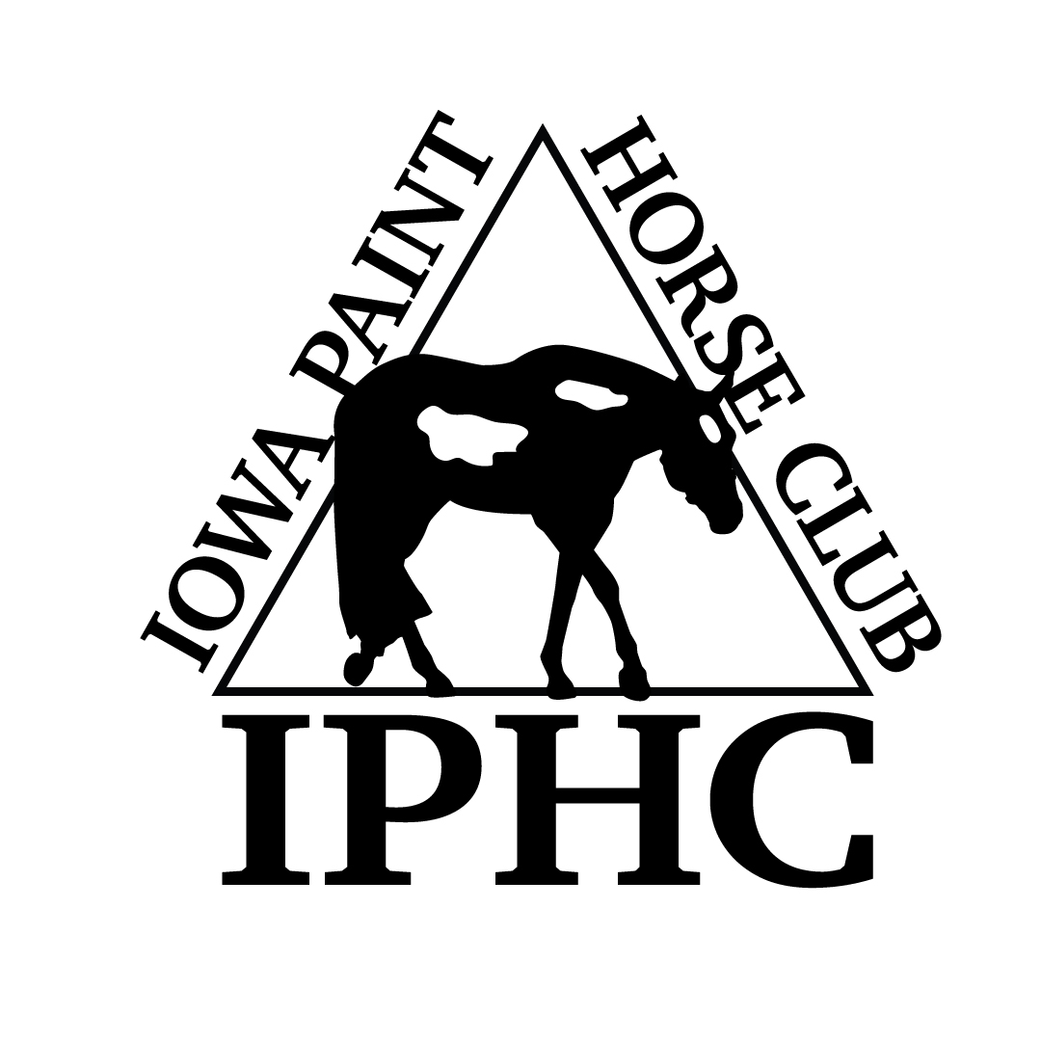
HORSE REGISTRATION PAPERS MUST BE IN HAND FOR VERIFICATION OF OWNERSHIP. CURRENT MEMBERSHIP CARDS, BOTH OWNER & EXHIBITOR MUST BE PRESENTED AT THE SHOW.
IOWA PAINT HORSE CLUB – 2017 ENTRY FORM
Back #
April 26-27, 2014 2014

Name of person who will be paying this horses’s fees:

HORSE INFORMATION (As it appears on the Registration Papers)

- Mare
- Gelding
- Stallion
Registered Name Reg. #: Foal Year

Trainer/Stalled With

OWNER INFORMATION (As it appears on the Registration Papers)

{jpj

Owner APHA # Exp.Date Phone #

Address City,State, Zip

Email

EXHIBITOR INFORMATION (Date of Birth “DOB” required for Youth only)
DP)

EXHIBITOR # 1

EXHIBITOR # 2
Name  APHA # Exp.Date DOB  Address  City,State,Zip  Phone Email  Relationship to Owner  Rider Status: ___ Open ____Amateur ____Novice _____Youth | Name  APHA # Exp.Date DOB  Address  City,State,Zip  Phone Email  Relationship to Owner  Rider Status: ___ Open ____Amateur ____Novice _____Youth
# 1  EXHIBITOR # 3  Name  APHA # Exp.Date DOB  Address  City,State,Zip  Phone Email  Relationship to Owner  Rider Status: ___ Open ____Amateur ____Novice _____Youth | SHOW FEES  ALL FEES REPRESENT A PER DAY/PER HORSE FEE  FEES INCLUDE ALL FEES AND # OF CLASSES INDICATED  - 4 CLASSES OR MORE - $80/PER HORSE, PER DAY  - 2-3 CLASSES - $55/PER HORSE, PER DAY  - 1 CLASS - $30/PER HORSE, PER DAY  Stalls- $60, required to purchase 2 bags of shavings for all horse stalls. Shavings - $7.50/bag.  Lead Line Class (Class 91) – Free  Amateur 45 & Over Western Pleasure (Cl. 102) $6/per judge  NOTES: 1) Exhibitors may not show in both Am. W-T and 45 & Over Western Pleasure. 2) Amateur 45 & Over only APHA registered or SPB allowed. 3) Longeline: APHA rules. 4) Show management reserves the right to combine classes. 5) ALL HORSES MUST HAVE A STALL – NO JUMP OUTS ALLOWED
 |  | SAT |  | SUN |  |  | SAT | SUN |  |  | SAT | SUN
23 | Yth W-T Showmanship 5-10 |  |  |  | 1 | Amateur Pleasure Driving |  |  | 2 | Pleasure Driving
24 | Nov Youth Showmanship 18/U |  |  |  | 4 | Amateur Stallions – All Ages |  |  | 3 | Utility Driving *July & Oct Only*
25 | Youth Showmanship 18/U |  |  |  | 7 | Am. SPB Stallions – All Ages |  |  | 10 | Junior SPB Stallions (2 & Under)
29 | Youth Mares |  |  |  | 22 | Amat Walk-Trot Showmanship |  |  | 11 | Senior SPB Stallions (3 & Over)
49 | Youth Geldings |  |  |  | 26 | Novice Amateur Showmanship |  |  | 14 | Performance Halter Stallions
74 | Yth W-T Hunter U/Saddle 5-10 |  |  |  | 27 | Amateur Showmanship |  |  | 15 | Weanling Stallions
76 | Yth W-T Hunt Seat Eq 5-10 |  |  |  | 28 | SPB Amateur Showmanship |  |  | 16 | Yearling Stallions
77 | Nov Yth Hunter U/Saddle 18/U |  |  |  | 30 | Amateur Mares |  |  | 17 | Two Year Old Stallions
78 | Yth Hunter U/Saddle 18/U |  |  |  | 33 | Amateur SPB Mares - All Ages |  |  | 18 | Three Year Old Stallions
84 | Nov Yth Hunt Seat Eq 18/U |  |  |  | 50 | Amateur Geldings |  |  | 19 | Four Year & Older Stallions
85 | Yth Hunt Seat Eq 18/Under |  |  |  | 53 | Amateur SPB Geldings-All Ages |  |  | 36 | SPB Mares (2 Years & Under)
88 | Youth Hunter Hack 18/U |  |  |  | 69 | Amateur Yearling Longe Line (not at April show) |  |  | 37 | SPB Mares (3 Years & Over)
91 | Lead Line 8 & Under |  |  |  | 73 | Amat W-T Hunter U/Saddle |  |  | 40 | Performance Halter Mares
94 | Yth W-T Western Pleasure 5-10 |  |  |  | 75 | Amateur Walk-Trot Equitation |  |  | 41 | Weanling Mares
95 | Yth W-T Horsemanship 5-10 |  |  |  | 80 | Nov Am Hunter Under Saddle |  |  | 42 | Yearling Mares
99 | Nov Yth West Pleasure 18/U |  |  |  | 81 | Amat Hunter Under Saddle |  |  | 43 | Two Year Old Mares
100 | Yth Western Pleasure 18/U |  |  |  | 82 | SPB Amat Hunter U/Saddle |  |  | 44 | Three Year Old Mares
106 | Nov Yth Horsemanship 18/U |  |  |  | 86 | Novice Am Hunt Seat Eq |  |  | 45 | Four Year & Older Mares
107 | Youthth Horsemanship 18/U |  |  |  | 87 | Amateur Hunt Seat Eq |  |  | 46 | Broodmares
110 | Youth Western Riding 18/U |  |  |  | 89 | Amateur Hunter Hack |  |  | 56 | SPB Geldings (2 Years & Under)
116 | Youth Walk-Trot Trail 5-10 |  |  |  | 93 | Amat W-T Western Pleasure |  |  | 57 | SPB Geldings (3 Years & Over)
117 | Novice Youth Trail 18/U |  |  |  | 96 | Amateur W-T Horsemanship |  |  | 60 | Performance Halter Geldings
118 | Youth Trail 18/U |  |  |  | 102 | Amat 45 & Over West Pleasure (NO APHA Points) |  |  | 61 | Yearling Geldings
123 | Youth Ranch Riding 18/U |  |  |  | 103 | Nov Am Western Pleasure |  |  | 62 | Two Year Old Geldings
126 | Youth Reining 18/U |  |  |  | 104 | Amateur Western Pleasure |  |  | 63 | Three Year Old Geldings
129 | Youth Barrels 18/U |  |  |  | 105 | SPB Amateur West Pleasure |  |  | 64 | Four Year & Older Geldings
132 | Youth Poles 18/U |  |  |  | 108 | Nov Amateur Horsemanship |  |  | 67 | Overo Color
135 | Youth Stake Race 18/U |  |  |  | 109 | Amateur Horsemanship |  |  | 68 | Tobiano Color
 |  |  |  |  | 112 | Amateur Western Riding |  |  | 70 | SPB Yearling Longe Line (not at April show)
Horses are entered at your own risk and are subject to each specific association rules under which these classes will be conducted. In case of death, accident, injury or theft to the exhibitor, their family, horses or property, no claims will be honored either against this show or managing facility. |  |  |  |  | 115 | Amateur Walk-Trot Trail |  |  | 71 | Yearling Longe Line (not at April show)
 |  |  |  |  | 120 | Novice Amateur Trail |  |  | 72 | SPB Hunter Under Saddle
 |  |  |  |  | 121 | Amateur Trail |  |  | 79 | Green Hunter Under Saddle
 |  |  |  |  | 124 | Amateur Ranch Riding |  |  | 83 | Hunter Under Saddle
 |  |  |  |  | 127 | Amateur Reining |  |  | 90 | Hunter Hack
 |  |  |  |  | 130 | Amateur Barrels |  |  | 92 | Green Western Pleasure
 |  |  |  |  | 133 | Amateur Poles |  |  | 97 | SPB Western Pleasure
 |  |  |  |  | 136 | Amateur Stake Race |  |  | 98 | Junior Western Pleasure
 |  |  |  |  | *Horses may enter either regular halter or performance halter, not both. This does not prohibit a horse from being shown in a Youth and/or Amateur halter class in addition to the  open age-group/performance halter class. Horses entered in performance halter MUST enter and participate in a performance class, other than showmanship, that same day. |  |  |  | 101 | Senior Western Pleasure
 |  |  |  |  |  |  |  |  | 111 | Green Western Riding
 |  |  |  |  |  |  |  |  | 113 | Western Riding
# STALLS ____________# TACK STALLS__________  SHAVINGS __________ NUMBER FEE __________  CAMPING ____________NIGHTS |  |  |  |  |  |  |  |  | 114 | Yearling In-Hand Trail (not at April show)
 |  |  |  |  |  |  |  |  | 119 | Green Trail
 |  |  |  |  |  |  |  |  | 122 | Trail
 |  |  |  |  |  |  |  |  | 125 | Ranch Riding
 |  |  |  |  |  |  |  |  | 128 | Reining
 |  |  |  |  |  |  |  |  | 131 | Barrels
 |  |  |  |  | Please complete and email to westphal@partnercom.net or mail to Cindy Westphal, 13696 N. 107th Ave E – Gilman, IA 50106 |  |  |  | 134 | Poles
Youth/Novice Youth Classes
Amateur/Novice Amateur Classes
Open Classes

